Chromebook Reset
These directions will reset a Chromebook back to its original state connected to the BCPS Enterprise account. Any locally saved data will be deleted and is not recoverable.
- With the Chromebook powered ON press and HOLD the 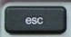, 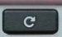 and the buttons until the device screen looks like below.
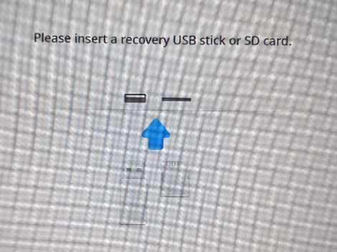
- Press and .
- The following screen will appear. Press Enter.
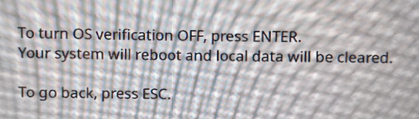
- The screen will go black. And then the following screen will appear. Press Enter.
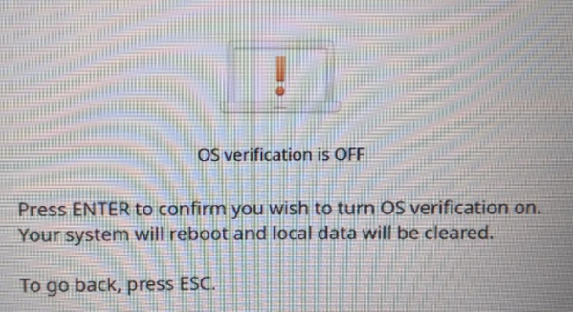
- The following screen will appear and then the system will reboot.
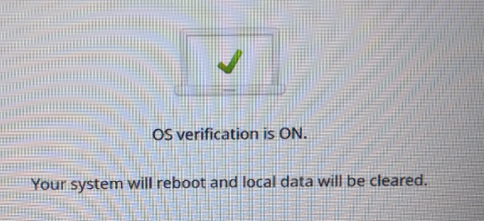
- The following screen will appear briefly.
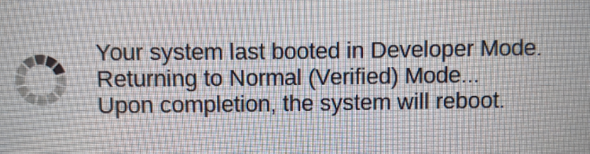
- On the Welcome screen click Let’s Go.
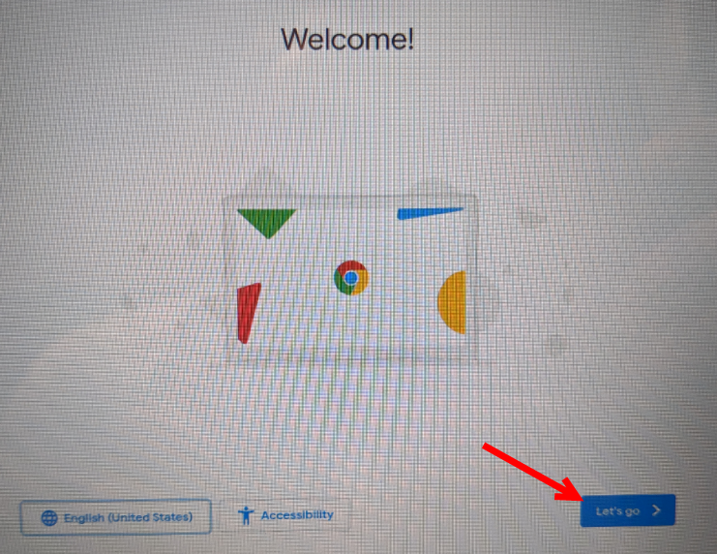
- Touch the Guest Network NOT secure.
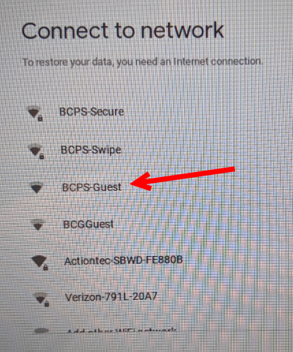
- Click Accept and Continue.
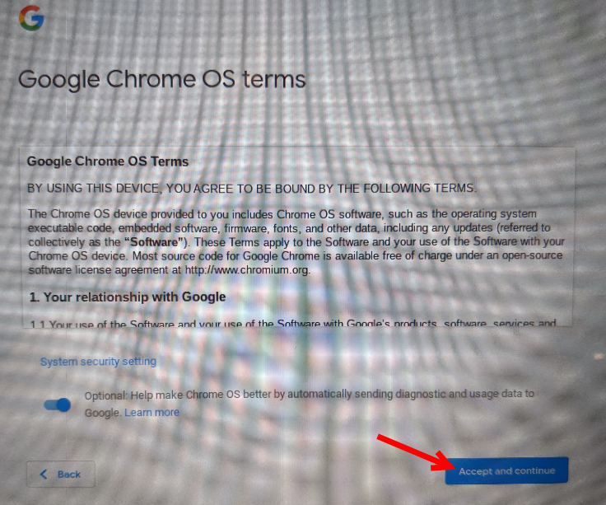
- Click Accept.
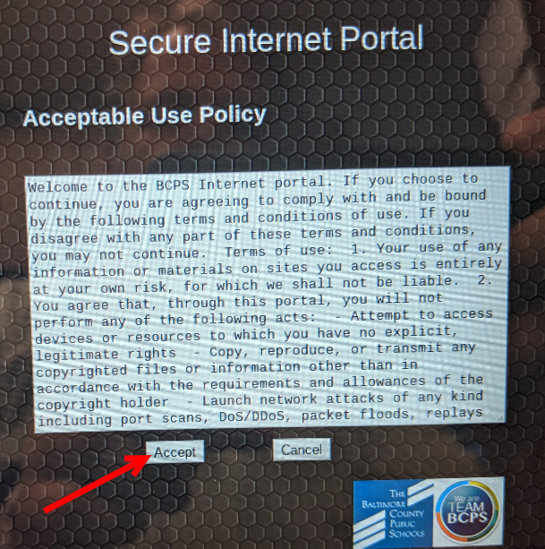
- The Enterprise Enrollment screen will appear. Type in Your User Name the @bcps.org is already provided. (If @bcps.org is NOT there you must call in a BCPS Serve ticket to have the machine joined properly to our BCPS Enterprise account.)
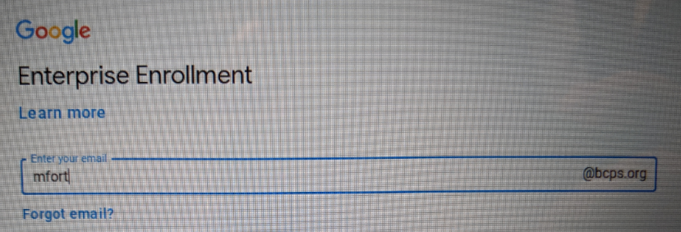
- Enter your BCPS password.
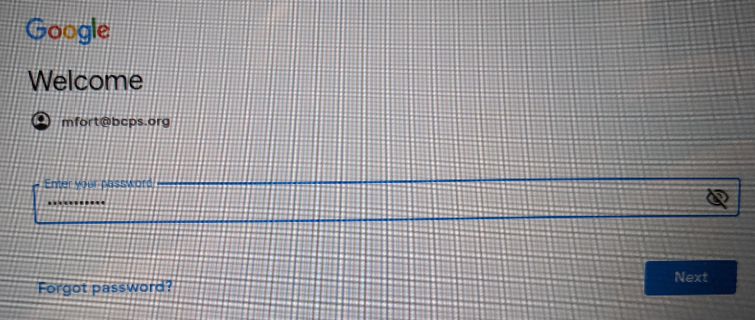
- Click Done.
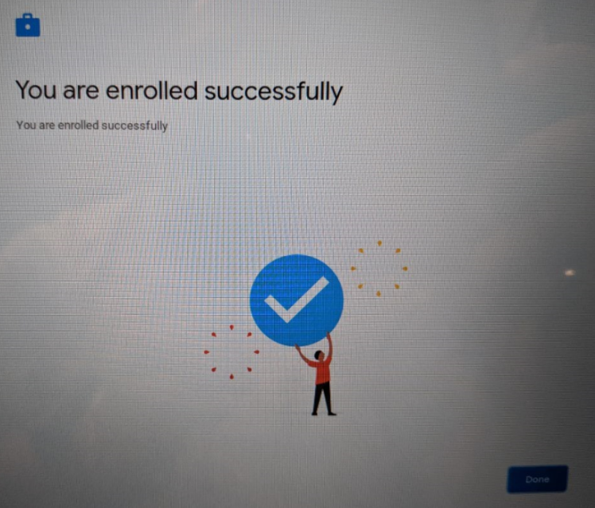
- The machine is now ready to use. All data has been wiped.

