Annual Student Information Review Form – Focus Parent Portal

Parents have the ability to complete the Annual Student Information Review Form through the Parent Portal in Focus. Parents should complete the following steps for each of their children.

Parents will log into their Focus Parent Portal. On the home screen, parents will select Not Yet started – Click to begin in English [EN] to begin completing the form for each of their students. See Figure 1.
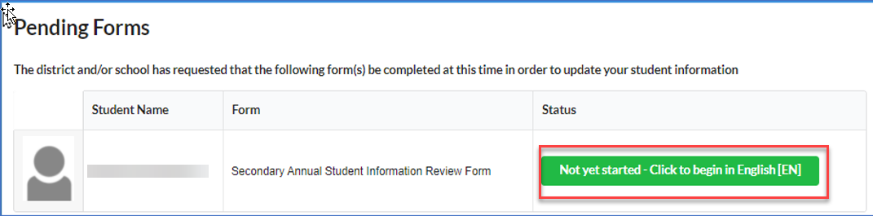
Figure 1
Parents will follow the prompts on the screen to complete the form. After they have completed the form, select Submit and Finish. See Figure 2.
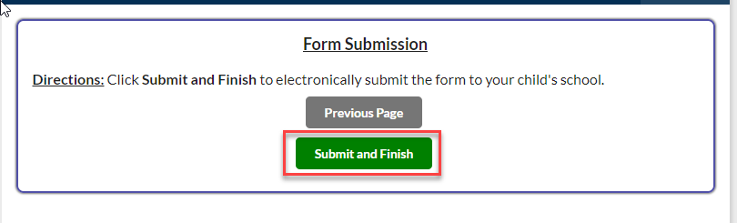
Figure 2
Parents will select Click here to return to the Portal. See Figure 3.
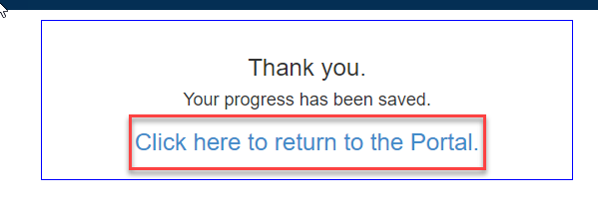
Figure 3

